TJA, 9. razred
ponedeljek, 20. 4. 2020 (12. šolska ura dela na daljavo)
Bližamo se koncu 4. enote Heroes. Čaka nas še utrjevanje novo pridobljenega znanja, potem pa preverjanje … za katerega pa še ne vemo, v kakšni obliki. O vsem boste pravočasno obveščeni, zato naj vas nič ne skrbi. Zdaj je čas, da malo razmislite, kaj ste se do sedaj naučili, kaj vam gre, kaj vam ne gre in pri čem potrebujete še dodatno razlago in pomoč. Prosimo, da nam pišete, da vam bomo lahko pomagale.

Danes boste ponovili besedišče, povezano s srednjeveškimi vitezi, ter utrjevali tvorbo pridevnikov s končnicama –ed in –ing. Vadili boste rabo glagolov, ki jim sledi glagol s končnico –ing ali nedoločnik. Prav tako pa boste utrjevali uporabo slovničnih struktur there's someone / something + -ing ter see / hear someone + -ing.

Ne pozabite nam svojega dela poslati do petka, 24. aprila.

Sledite spodnjim navodilom. Vaje lahko rešujete v zvezek (učbenik, stran 54, in delovni zvezek, stran 42 in 43) ali pa kar v ta dokument, tako da kliknete na okenca, kamor lahko vnašate svoje besedilo ali pa izberete pravi odgovor (dokument sproti shranjujte, da nam ga boste lahko poslali z vnesenimi vašimi rešitvami). Če potrebujete pomoč pri tem, sporočite.

REVISION
Grammar
1 Describe the picture. Write ten sentences.
example: There are two girls roller-blading.
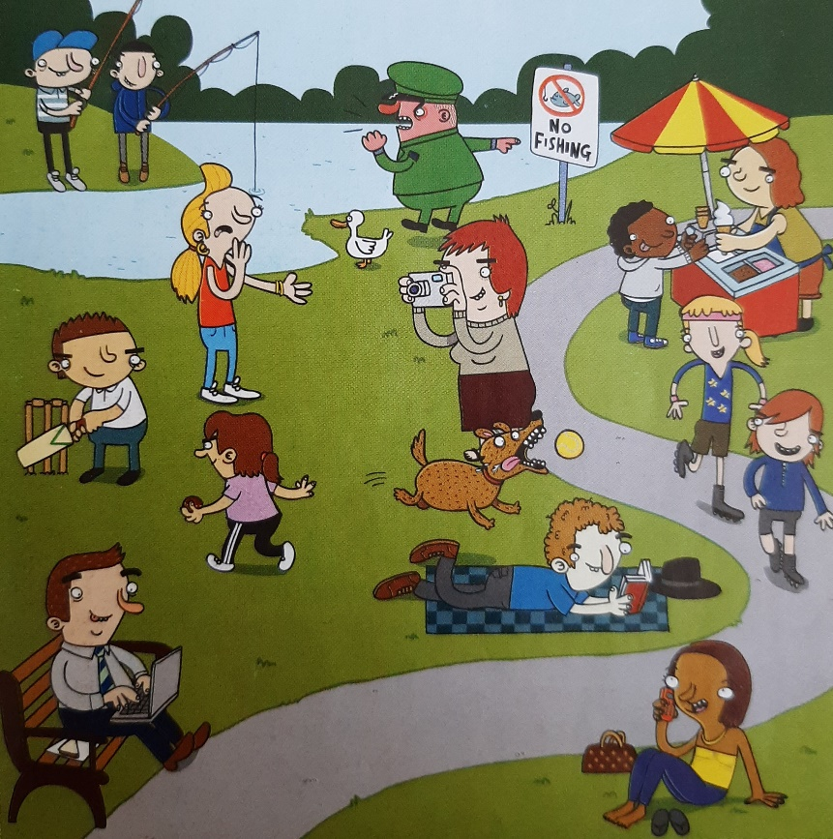
- Kliknite ali tapnite tukaj, če želite vnesti besedilo.
- Kliknite ali tapnite tukaj, če želite vnesti besedilo.
- Kliknite ali tapnite tukaj, če želite vnesti besedilo.
- Kliknite ali tapnite tukaj, če želite vnesti besedilo.
- Kliknite ali tapnite tukaj, če želite vnesti besedilo.
- Kliknite ali tapnite tukaj, če želite vnesti besedilo.
- Kliknite ali tapnite tukaj, če želite vnesti besedilo.
- Kliknite ali tapnite tukaj, če želite vnesti besedilo.
- Kliknite ali tapnite tukaj, če želite vnesti besedilo.
- Kliknite ali tapnite tukaj, če želite vnesti besedilo.
2 Describe what you can see, hear of feel if you imagine yourself at these scenes.
example:
a rock concert – I can hear two women singing. I can see a man with long hair playing the drums. I can feel the floor vibrating.
- a robbery Kliknite ali tapnite tukaj, če želite vnesti besedilo.
- a winter's day Kliknite ali tapnite tukaj, če želite vnesti besedilo.
- a rock concert Kliknite ali tapnite tukaj, če želite vnesti besedilo.
- autumn Kliknite ali tapnite tukaj, če želite vnesti besedilo.
- a football match Kliknite ali tapnite tukaj, če želite vnesti besedilo.
- at a swimming pool Kliknite ali tapnite tukaj, če želite vnesti besedilo.
3 Complete the sentences. Put the verbs in brackets into the correct form.
- We can go out now. It's stopped raining .(rain)
- Have you finished Kliknite ali tapnite tukaj, če želite vnesti besedilo.the computer? (use)
- We were tired, so we stopped Kliknite ali tapnite tukaj, če želite vnesti besedilo.a rest. (have)
- I can't go out. I promised Kliknite ali tapnite tukaj, če želite vnesti besedilo. in the house. (help)
- We've decided Kliknite ali tapnite tukaj, če želite vnesti besedilo. to the cinema tomorrow. (go)
- Do you enjoy Kliknite ali tapnite tukaj, če želite vnesti besedilo. reality TV shows? (watch)
- Oh, here's my mobile. I don't remember Kliknite ali tapnite tukaj, če želite vnesti besedilo. it here. (put)
- I wanted to watch that programmer, but I forgot Kliknite ali tapnite tukaj, če želite vnesti besedilo. it. (do)

4 Describe the picture. Use the expressions in the box.
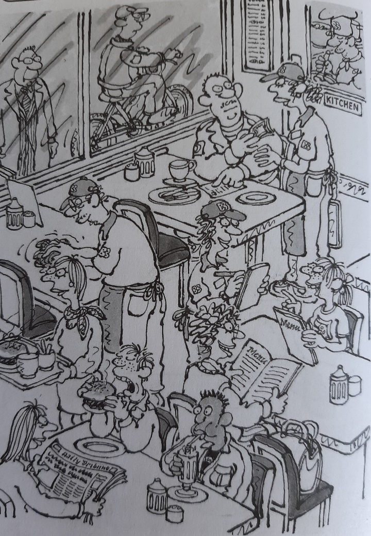
clean the tables | read a newspaper
look through the window | order a meal
look at the menu | pay the bill
cook meals | drink a milkshake
eat a hamburger | ride a bike
- There's a woman carrying a tray.
- Kliknite ali tapnite tukaj, če želite vnesti besedilo.
- Kliknite ali tapnite tukaj, če želite vnesti besedilo.
- Kliknite ali tapnite tukaj, če želite vnesti besedilo.
- Kliknite ali tapnite tukaj, če želite vnesti besedilo.
- Kliknite ali tapnite tukaj, če želite vnesti besedilo.
- Kliknite ali tapnite tukaj, če želite vnesti besedilo.
- Kliknite ali tapnite tukaj, če želite vnesti besedilo.
- Kliknite ali tapnite tukaj, če želite vnesti besedilo.
- Kliknite ali tapnite tukaj, če želite vnesti besedilo.
- Kliknite ali tapnite tukaj, če želite vnesti besedilo.

5 Complete the stories. Use the phrases in the boxes. Be careful to put them in the correct tense.
hear / some glass / break
see / the two boys / run away
hear / a man / shout

Yesterday, while I was walking along a street, I noticed two boys kicking a ball. As I was walking round the corner, I Kliknite ali tapnite tukaj, če želite vnesti besedilo.. I looked round and I Kliknite ali tapnite tukaj, če želite vnesti besedilo.. Then I Kliknite ali tapnite tukaj, če želite vnesti besedilo..

hear / the door / open
feel / something cold / touch / my face
hear / a dog / bark
see / my friend's dog / stand / by the bed

Last weekend, I slept at my friends house. In the middle of the night I Kliknite ali tapnite tukaj, če želite vnesti besedilo.. A few seconds later, I Kliknite ali tapnite tukaj, če želite vnesti besedilo.. I didn't know what it was. Then, I Kliknite ali tapnite tukaj, če želite vnesti besedilo.. I opened my eyes and I Kliknite ali tapnite tukaj, če želite vnesti besedilo.

Vocabulary
1 Play the online game: Dragon Bite
2 Choose the correct adjective.
- We had a good holiday. I feel very Izberite element..
- I was Izberite element. when the car didn't stop.
- Are you Izberite element. in sport?
- I liked the film. It was very Izberite element..
- Everybody was Izberite element. when Jane arrived.
- We can't go to the concert. I feel really Izberite element..
- We read a very Izberite element. story today.
- Do you feel Izberite element. about the exam?
3 Complete the dialogues with adjectives made from the verbs in the box.
worry | frighten | surprise | embarras | amuse | disappoint
- I can't go to New York with my parents.
  - Oh, that's dissapointing!
- I love that film.
  - Me, too. It's so Kliknite ali tapnite tukaj, če želite vnesti besedilo..
- I went on the stage and forgot all my words.
  - Were you Kliknite ali tapnite tukaj, če želite vnesti besedilo.?
- The whole family went away for the weekend.
  - I get Kliknite ali tapnite tukaj, če želite vnesti besedilo. when I'm on my own.
- Well done! You won the first prize.
  - Thanks! I was really Kliknite ali tapnite tukaj, če želite vnesti besedilo..
- Mum always gets Kliknite ali tapnite tukaj, če želite vnesti besedilo. when I'm out late.
- –That's normal!
4 Choose the correct words.
- The soldier was killed / wounded / survived in the fight and died a few days later.
- The Queen always wears a Izberite element. when she opens Parliament.
- My grandfather Izberite element. two world wars and died when he was 95.
- Knights used to wear heavy Izberite element.. They also carried to protect them.
- There were a lot of Izberite element. before the war ended.
- Soldiers in the past used Izberite element., not guns, to kill the enemy.
- You must wear a Izberite element. when you ride a motorbike.

Punctuation
1 Punctuate the sentences.
- where have you been frank asked the teacher
'Where have you been, Frank?', asked the teacher.
- ive been to see the nurse because ive got a bad leg said frank
Kliknite ali tapnite tukaj, če želite vnesti besedilo.
- I hope its better soon said miss jones heres your homework
Kliknite ali tapnite tukaj, če želite vnesti besedilo.
- I cant do any homework because my hand is bad too said frank
Kliknite ali tapnite tukaj, če želite vnesti besedilo.
- don't worry said miss jones if you stay behind after class im sure I can help you with it
Kliknite ali tapnite tukaj, če želite vnesti besedilo.

Listening and writing
6 Listen. Complete the requests. Use Could you … ? or Would you mind …?
The TV's too loud. Would you mind turning it down, please?
- Kliknite ali tapnite tukaj, če želite vnesti besedilo.
- Kliknite ali tapnite tukaj, če želite vnesti besedilo.
- Kliknite ali tapnite tukaj, če želite vnesti besedilo.
- Kliknite ali tapnite tukaj, če želite vnesti besedilo.
- Kliknite ali tapnite tukaj, če želite vnesti besedilo.

